LAB EXPERIMENTS

- Grayscale Conversion
CODE:
import cv2
img = cv2.imread(r"C:\Users\T Rohita Sai\Downloads\cute puppy.jpg")
if img is None:
print("Error loading image")
else:
gray = cv2.cvtColor(img, cv2.COLOR_BGR2GRAY)
cv2.imwrite(r"C:\Users\T Rohita Sai\Downloads\gray_output.jpg", gray)
cv2.imshow("Original", img)
cv2.imshow("Grayscale", gray)
cv2.waitKey(0)
cv2.destroyAllWindows()
OUTPUT:
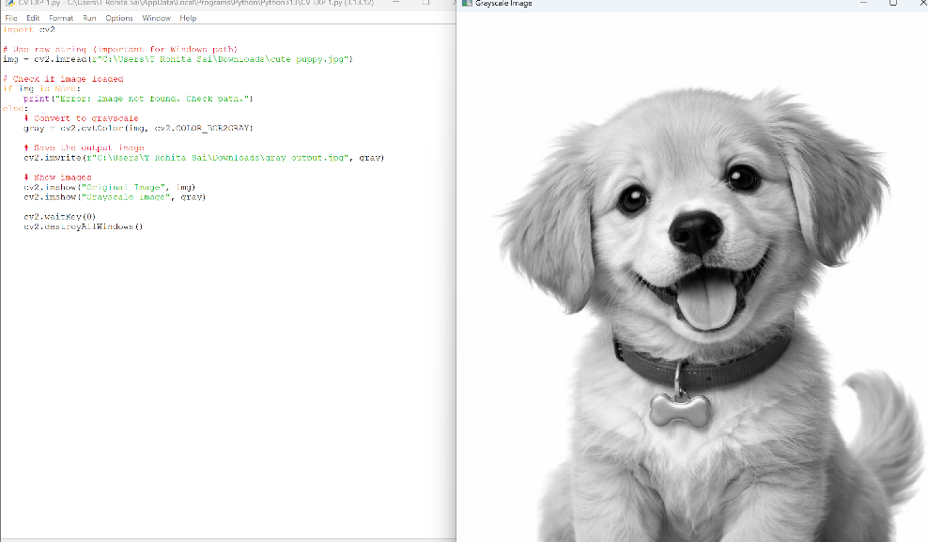

- Gaussian Blur
CODE:
import cv2
img = cv2.imread(r"C:\Users\T Rohita Sai\Downloads\cute puppy.jpg")
if img is None:
print("Error loading image")
else:
blur = cv2.GaussianBlur(img, (5,5), 0)
cv2.imwrite(r"C:\Users\T Rohita Sai\Downloads\blur_output.jpg", blur)
cv2.imshow("Original", img)
cv2.imshow("Blurred", blur)
cv2.waitKey(0)
cv2.destroyAllWindows()
OUTPUT:
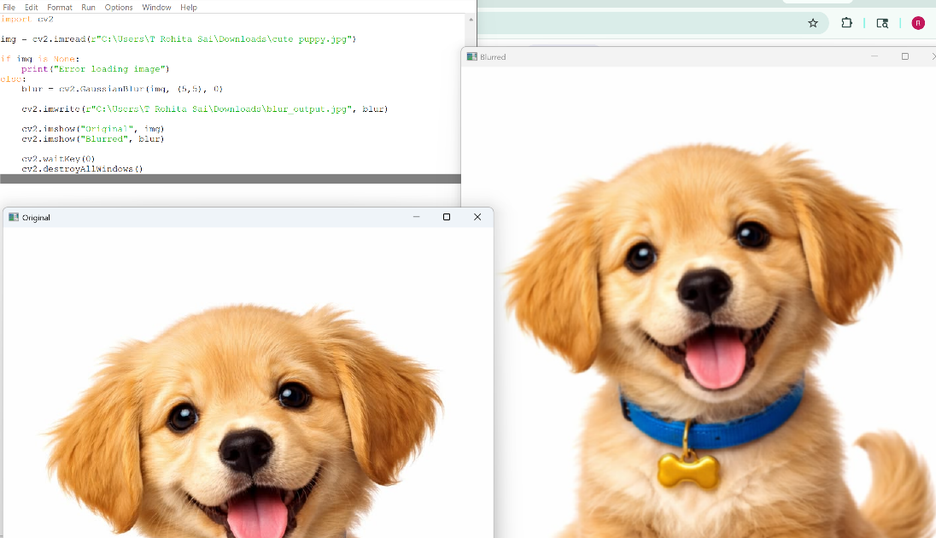

- Canny Edge Detection
CODE:
import cv2
img = cv2.imread(r"C:\Users\T Rohita Sai\Downloads\cute puppy.jpg")
if img is None:
print("Error loading image")
else:
gray = cv2.cvtColor(img, cv2.COLOR_BGR2GRAY)
edges = cv2.Canny(gray, 100, 200)
cv2.imwrite(r"C:\Users\T Rohita Sai\Downloads\edges_output.jpg", edges)
cv2.imshow("Edges", edges)
cv2.waitKey(0)
cv2.destroyAllWindows()
OUTPUT:

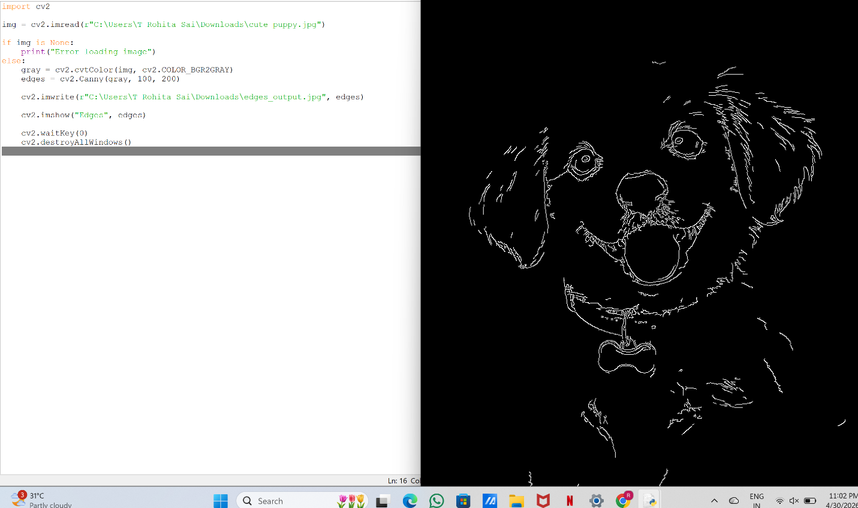
- Histogram Equalization
CODE:
import cv2
img = cv2.imread(r"C:\Users\T Rohita Sai\Downloads\cute puppy.jpg")
if img is None:
print("Error loading image")
else:
gray = cv2.cvtColor(img, cv2.COLOR_BGR2GRAY)
eq = cv2.equalizeHist(gray)
cv2.imwrite(r"C:\Users\T Rohita Sai\Downloads\equalized_output.jpg", eq)
cv2.imshow("Original Gray", gray)
cv2.imshow("Equalized", eq)
cv2.waitKey(0)
cv2.destroyAllWindows()
OUTPUT:

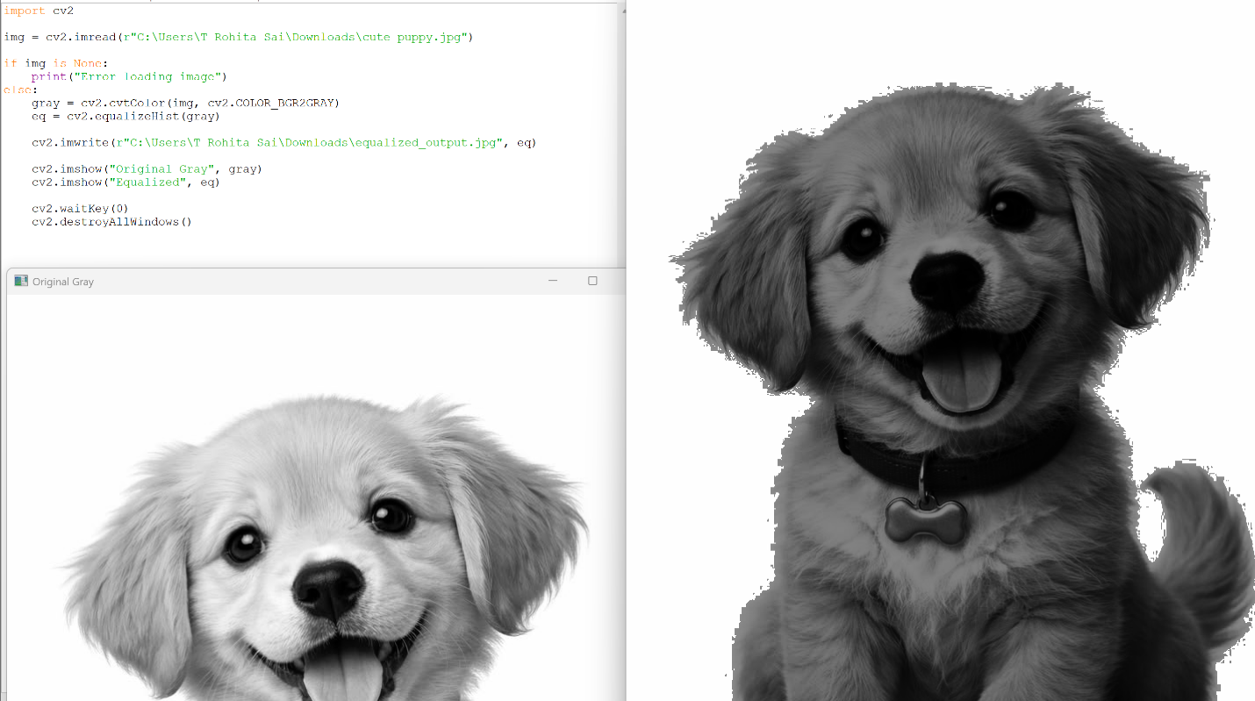
- Histogram Analysis (Color)
CODE:
import cv2
from matplotlib import pyplot as plt
img = cv2.imread(r"C:\Users\T Rohita Sai\Downloads\cute puppy.jpg")
if img is None:
print("Error loading image")
else:
colors = ('b','g','r')
for i, col in enumerate(colors):
hist = cv2.calcHist([img], [i], None, [256], [0,256])
plt.plot(hist, color=col)
plt.title("Color Histogram")
plt.xlabel("Pixel Value")
plt.ylabel("Frequency")
plt.show()

OUTPUT:
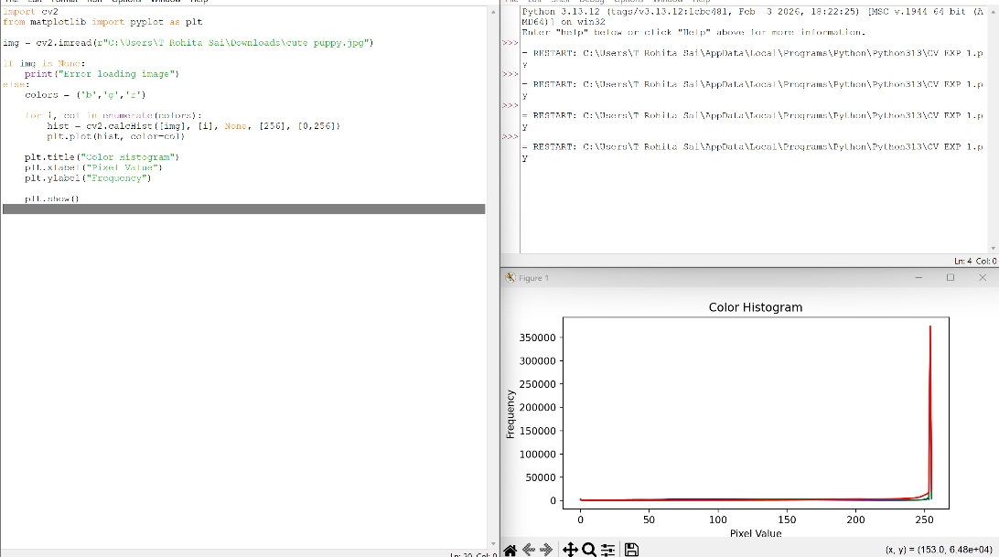

Experiment 6: Erosion (Erode Function)
Code
import cv2
import numpy as np
img = cv2.imread(r"C:\Users\T Rohita Sai\Downloads\cute puppy.jpg")
if img is None:
print("Error loading image")
else:
kernel = np.ones((5,5), np.uint8)
eroded = cv2.erode(img, kernel, iterations=1)
cv2.imwrite(r"C:\Users\T Rohita Sai\Downloads\eroded_output.jpg", eroded)
cv2.imshow("Original", img)
cv2.imshow("Eroded", eroded)
cv2.waitKey(0)
cv2.destroyAllWindows()
OUTPUT:
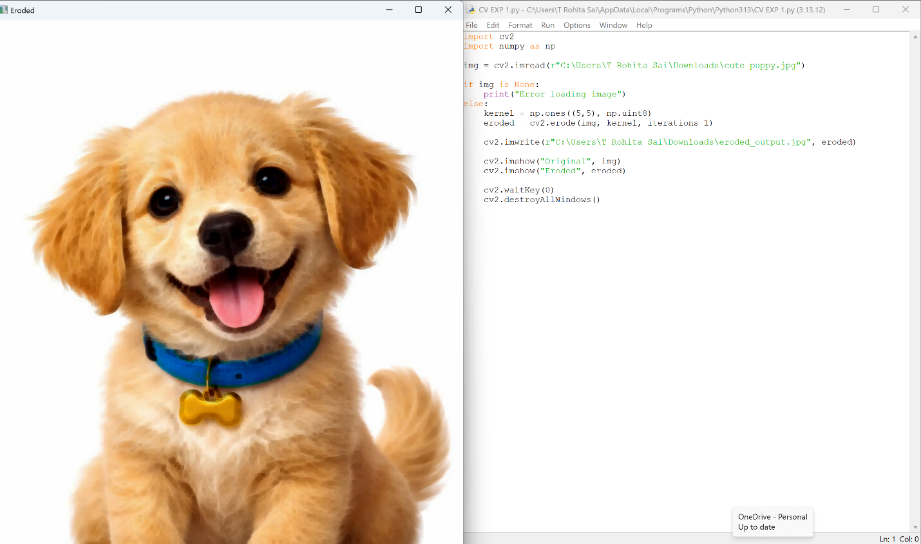

Experiment 7: Video Processing (Normal, Slow, Fast Motion)
Code
import cv2
cap = cv2.VideoCapture(0)
if not cap.isOpened():
print("Error opening camera")
else:
while True:
ret, frame = cap.read()
if not ret:
break
# Normal speed
cv2.imshow("Normal", frame)
# Slow motion (delay ↑)
cv2.imshow("Slow Motion", frame)
cv2.waitKey(100)
# Fast motion (almost no delay)
cv2.imshow("Fast Motion", frame)
if cv2.waitKey(1) & 0xFF == ord('q'):
break
cap.release()
cv2.destroyAllWindows()
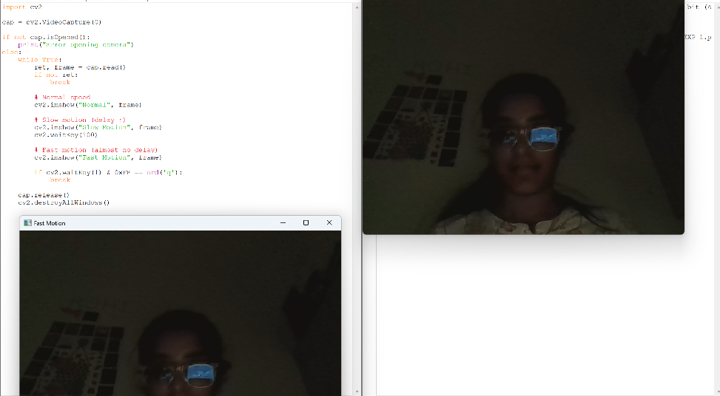
OUTPUT:

Experiment 8: Dilation
Code
import cv2
import numpy as np
img = cv2.imread(r"C:\Users\T Rohita Sai\Downloads\cute puppy.jpg")
if img is None:
print("Error loading image")
else:
kernel = np.ones((5,5), np.uint8)
dilated = cv2.dilate(img, kernel, iterations=1)
cv2.imwrite(r"C:\Users\T Rohita Sai\Downloads\dilated_output.jpg", dilated)
cv2.imshow("Original", img)
cv2.imshow("Dilated", dilated)
cv2.waitKey(0)
cv2.destroyAllWindows()
OUTPUT:
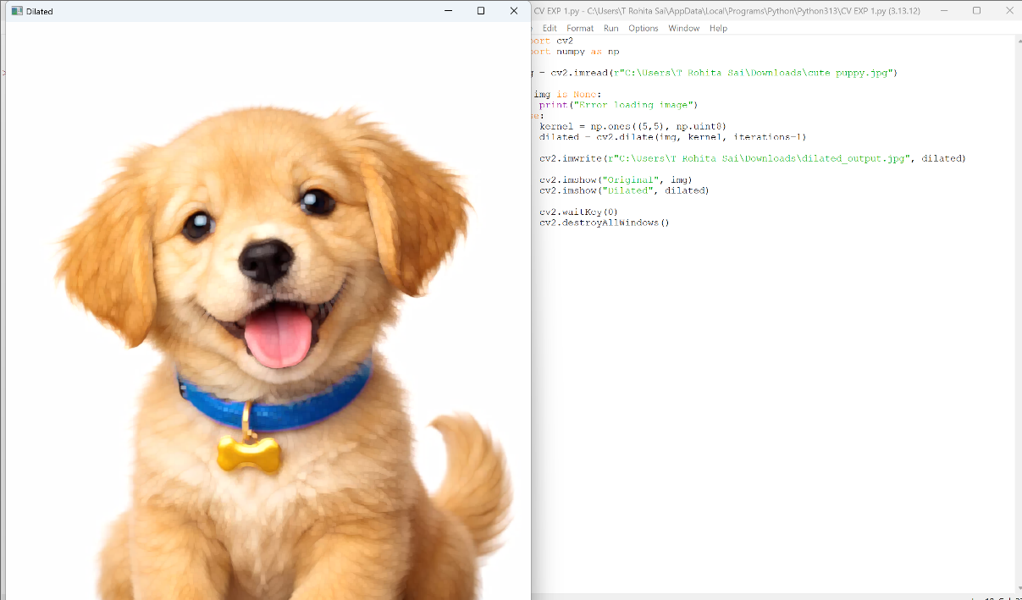

Experiment 9: Image Scaling (Resize Bigger & Smaller)
Code
import cv2
img = cv2.imread(r"C:\Users\T Rohita Sai\Downloads\cute puppy.jpg")
if img is None:
print("Error loading image")
else:
# Smaller image
small = cv2.resize(img, None, fx=0.5, fy=0.5)
# Bigger image
big = cv2.resize(img, None, fx=2, fy=2)
cv2.imwrite(r"C:\Users\T Rohita Sai\Downloads\small_output.jpg", small)
cv2.imwrite(r"C:\Users\T Rohita Sai\Downloads\big_output.jpg", big)
cv2.imshow("Original", img)
cv2.imshow("Small", small)
cv2.imshow("Big", big)
cv2.waitKey(0)
cv2.destroyAllWindows()
OUTPUT:
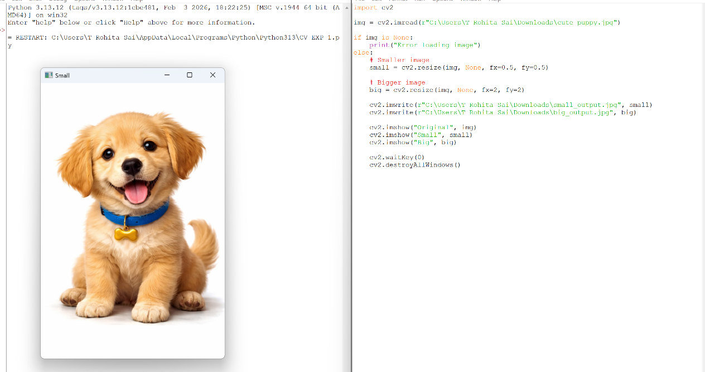

Experiment 10: 90° Rotation (Clockwise)
Code
import cv2
img = cv2.imread(r"C:\Users\T Rohita Sai\Downloads\cute puppy.jpg")
if img is None:
print("Error loading image")
else:
rotated = cv2.rotate(img, cv2.ROTATE_90_CLOCKWISE)
cv2.imwrite(r"C:\Users\T Rohita Sai\Downloads\rotated_output.jpg", rotated)
cv2.imshow("Original", img)
cv2.imshow("Rotated 90 CW", rotated)
cv2.waitKey(0)
cv2.destroyAllWindows()
OUTPUT:
